**School of Computer Science Engineering & Information Science**

**Report on**

**Weather Forcasting Dataset**

**Date : 15-05-2024 Time:11.00AM-12.50PM**

**Course: Data Analysis And Visualization**

**Course Code**: **CSE2015**

**Activity Conducted By**.

|  |  |  |
| --- | --- | --- |
| **S.No.** | **Roll No.** | **Name** |
| **1** | **20211IST0004** | **ANEESH K** |
| **2** | **20211IST0018** | **RAJAVARDHAN R** |
| **3** | **20211IST0022** | **ARSALAN ALI KHAN** |

**Topic : Analysis and Visualization of Weather Forcasting Dataset**

**Abstract:**

Weather forecasting is a critical aspect of daily life, impacting various sectors such as agriculture, transportation, and emergency preparedness. The ability to accurately predict weather conditions is essential for making informed decisions and mitigating potential risks. Data visualization plays a crucial role in enhancing the understanding and interpretation of weather forecast data. This abstract explores the significance of data visualization in weather forecasting, highlighting its role in presenting complex weather data in a comprehensible and actionable format. By employing various visualization techniques such as maps, charts, and graphs, meteorologists can communicate forecast information effectively to both experts and the general public. This abstract discusses the benefits of data visualization in weather forecasting, including improved decision-making, enhanced situational awareness, and increased public engagement. Additionally, it examines emerging trends and technologies in weather visualization, such as interactive dashboards and immersive visual experiences, which further enhance the usability and accessibility of weather forecast information. Overall, data visualization serves as a powerful tool for transforming raw weather data into meaningful insights, empowering individuals and organizations to make informed decisions and better prepare for future weather events.

**Introduction:**

Weather forecasting is a critical aspect of modern life, influencing everything from daily commutes to agricultural planning and disaster preparedness. In recent years, the field of weather forecasting has undergone a profound transformation with the advent of data-driven methodologies. Traditional forecasting methods relied heavily on meteorological theories and historical observations, but the abundance of data generated by satellites, weather stations, and other sources has opened up new possibilities for predictive accuracy.

Data-driven weather forecasting leverages advanced computational techniques, including machine learning and statistical modeling, to analyze vast amounts of meteorological data in real-time. This approach enables meteorologists to generate more accurate and timely forecasts, enhancing our ability to anticipate and respond to weather-related events.

In this paper, we will explore the principles, methodologies, and challenges associated with data-driven weather forecasting. We will examine the various sources of data used in forecasting, the techniques employed to analyze this data, and the implications for improving forecast accuracy and lead times. Additionally, we will discuss the role of emerging technologies such as artificial intelligence and big data analytics in shaping the future of weather forecasting.

By harnessing the power of data, meteorologists can provide society with more reliable and actionable weather forecasts, ultimately helping to mitigate risks and improve resilience in the face of changing weather patterns and extreme events.

**Problem Statement:**

Weather forecasting relies on vast amounts of data from various sources, including satellites, weather stations, and atmospheric models. However, effectively interpreting this data and communicating forecast information to stakeholders remains a challenge. Traditional methods of presenting weather forecasts, such as textual descriptions and numerical data tables, may not always convey the complexity of weather patterns and their potential impact on different regions and sectors. This lack of clarity and accessibility hinders decision-making and preparedness efforts, leading to inefficiencies and increased vulnerability to weather-related hazards.

**Architecture:**

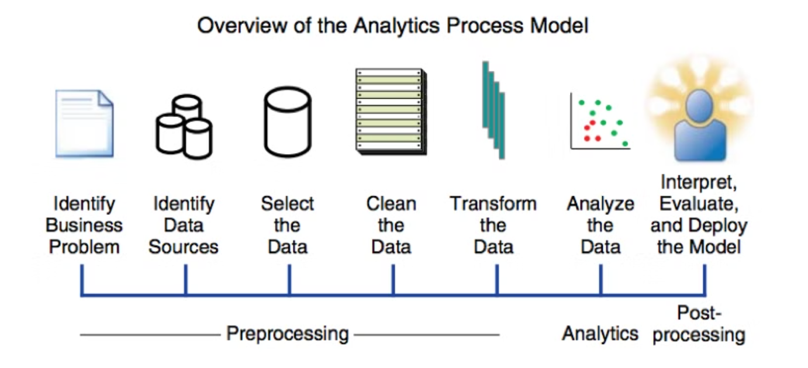

The analytic process model provides a structured framework for conducting data analysis. It encompasses a series of steps that guide analysts through the process of transforming raw data into meaningful insights. While specific methodologies may vary depending on the context and objectives of the analysis, the analytic process model typically consists of the following key stages:

1. **Define Objectives:** The first step involves clearly defining the objectives and goals of the analysis. This includes identifying the problem to be addressed, the questions to be answered, and the desired outcomes.

2. **Data Collection:** In this stage, relevant data sources are identified, and data is collected from various sources such as databases, surveys, sensors, or external sources. Quality assurance processes may also be implemented to ensure the accuracy and reliability of the data.

3. **Data Preparation:** Raw data often requires preprocessing before it can be analyzed effectively. This stage involves cleaning the data to remove errors, inconsistencies, and missing values. Data may also be transformed, aggregated, or normalized to facilitate analysis.

4. **Data Exploration:** Once the data is prepared, analysts explore it to gain insights and identify patterns, trends, and relationships. Exploratory data analysis techniques, such as visualization and descriptive statistics, are commonly used in this stage to summarize and understand the characteristics of the data.

5. **Data Analysis:** In this stage, more advanced analytical techniques are applied to extract meaningful information from the data. This may involve statistical analysis, machine learning algorithms, predictive modeling, or other quantitative methods depending on the objectives of the analysis.

6. **Interpretation and Evaluation:** The insights generated from the analysis are interpreted in the context of the original objectives. Analysts assess the relevance and significance of the findings and evaluate their implications for decision-making. This stage may also involve validating the results against external criteria or benchmarks.

7. **Communication and Reporting:** Finally, the findings of the analysis are communicated to stakeholders through reports, presentations, or other means. Clear and concise communication is essential to ensure that decision-makers understand the implications of the analysis and can take appropriate action based on the insights provided.

**Outcomes:**

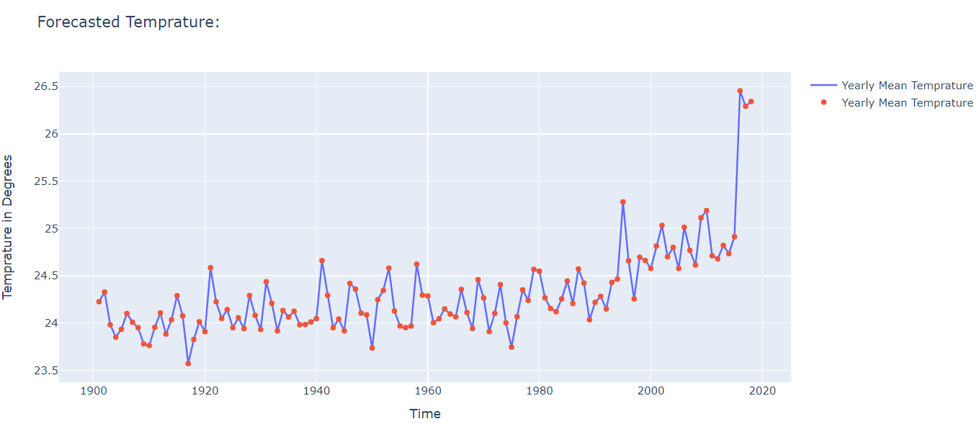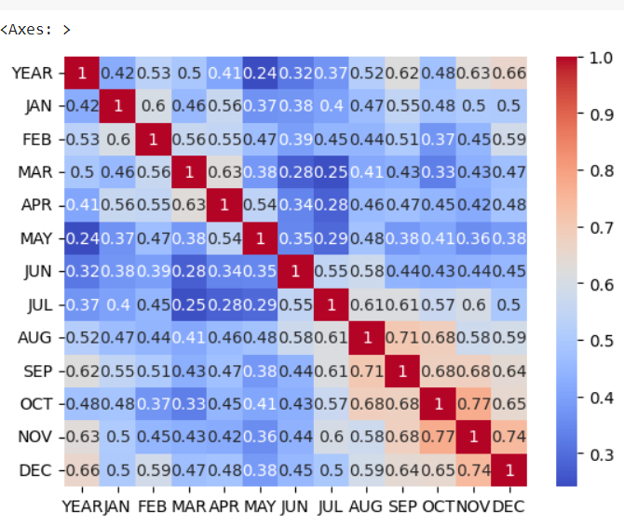

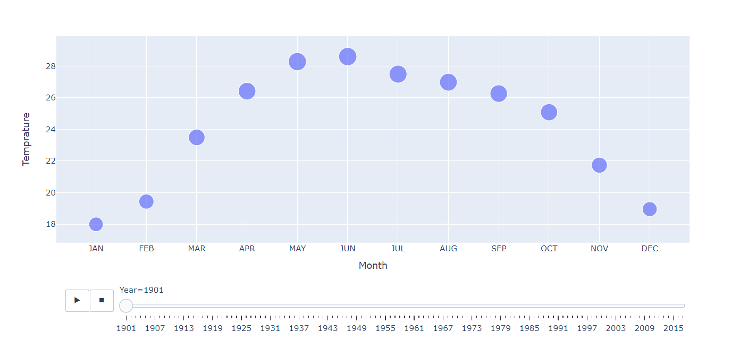

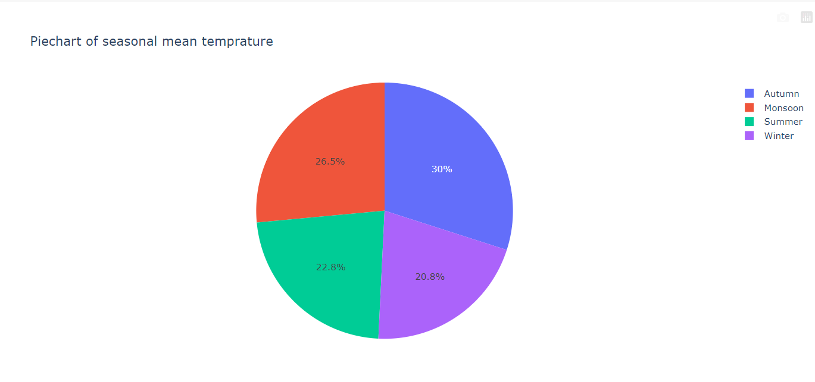

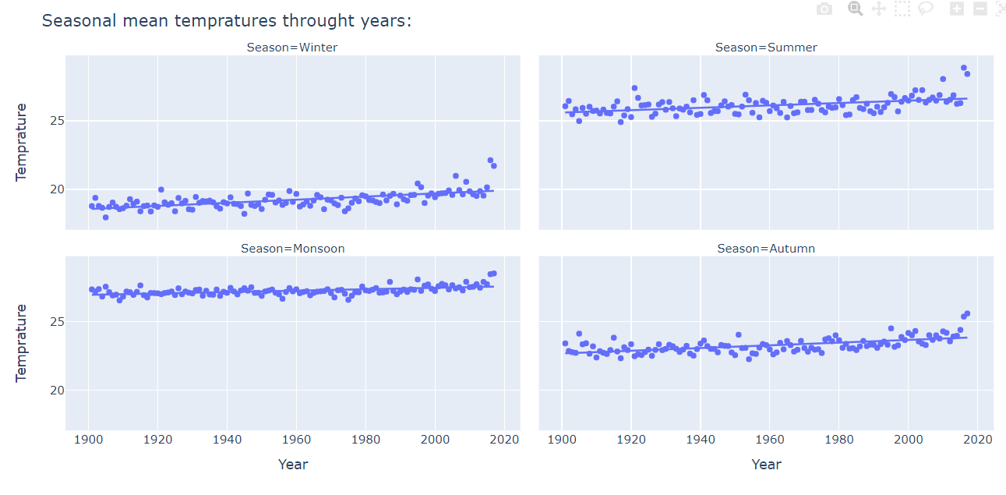

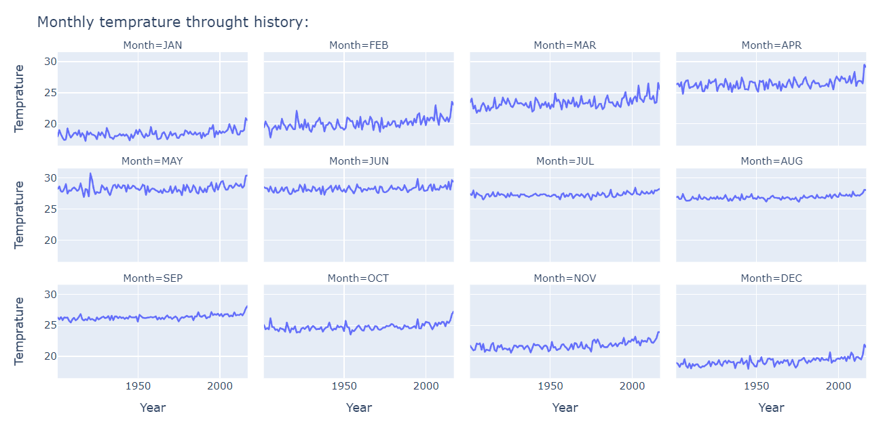

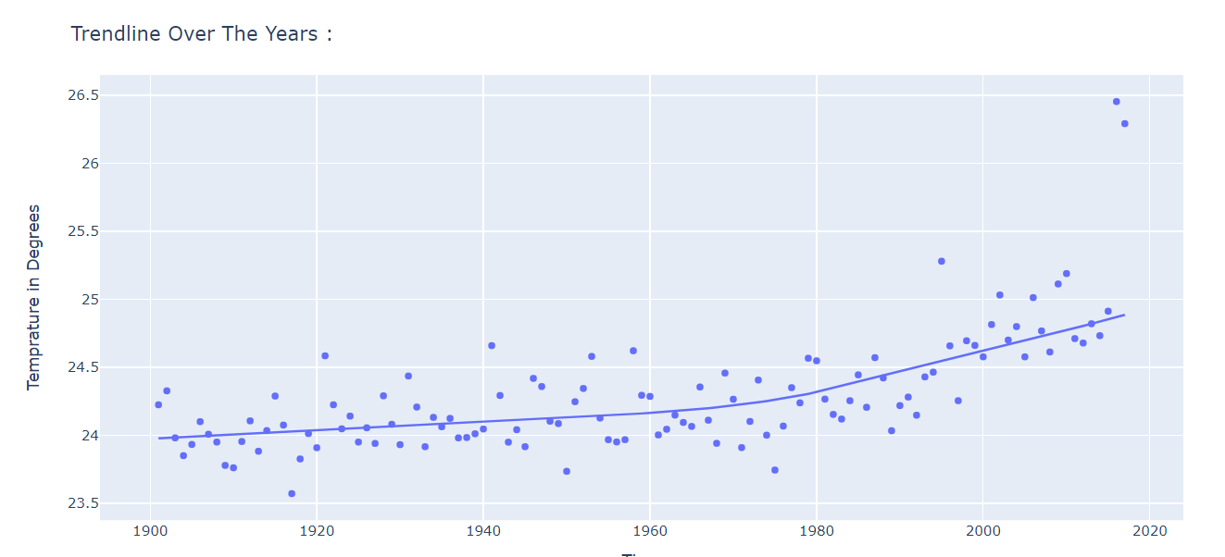

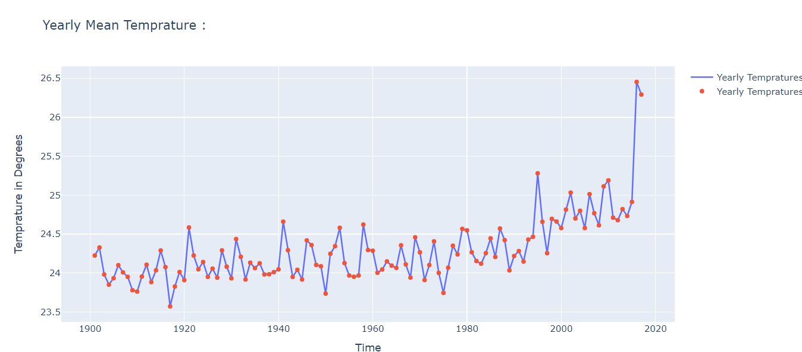

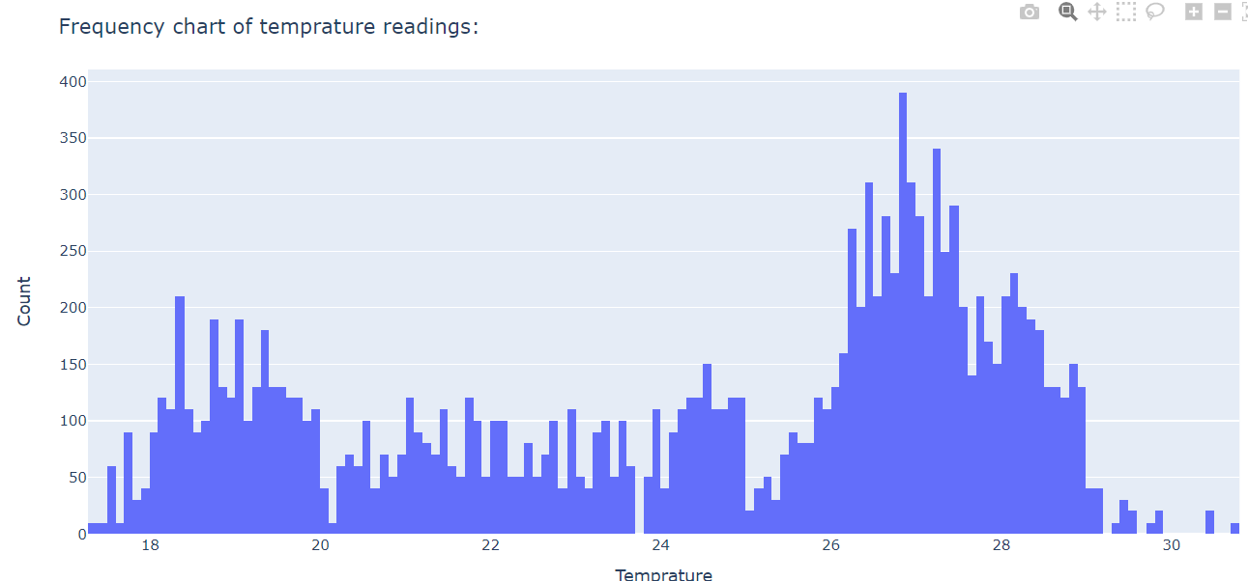

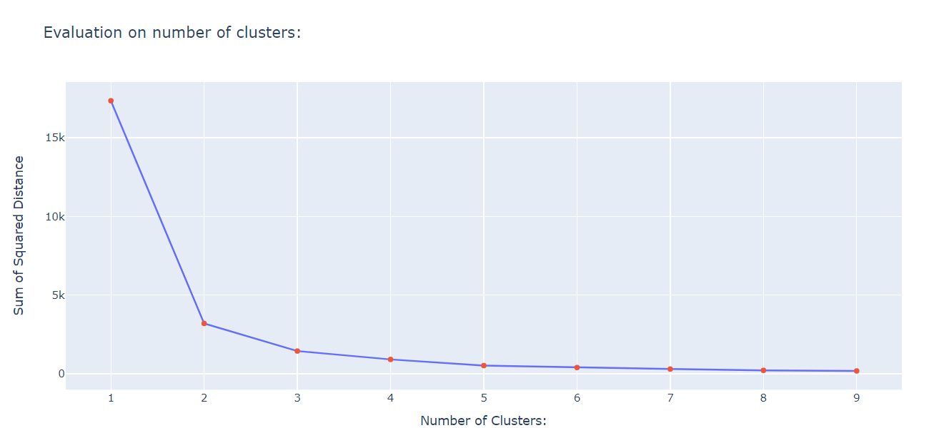

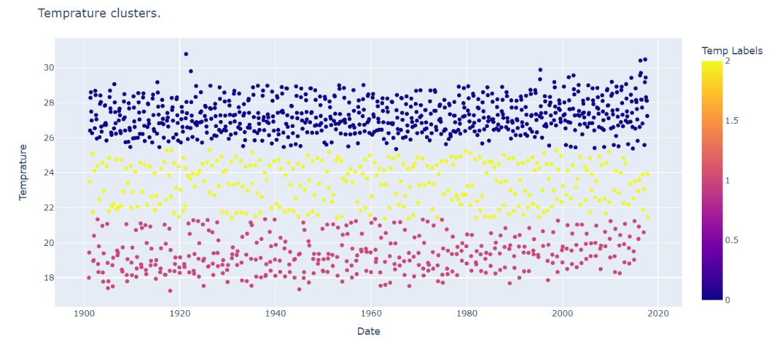

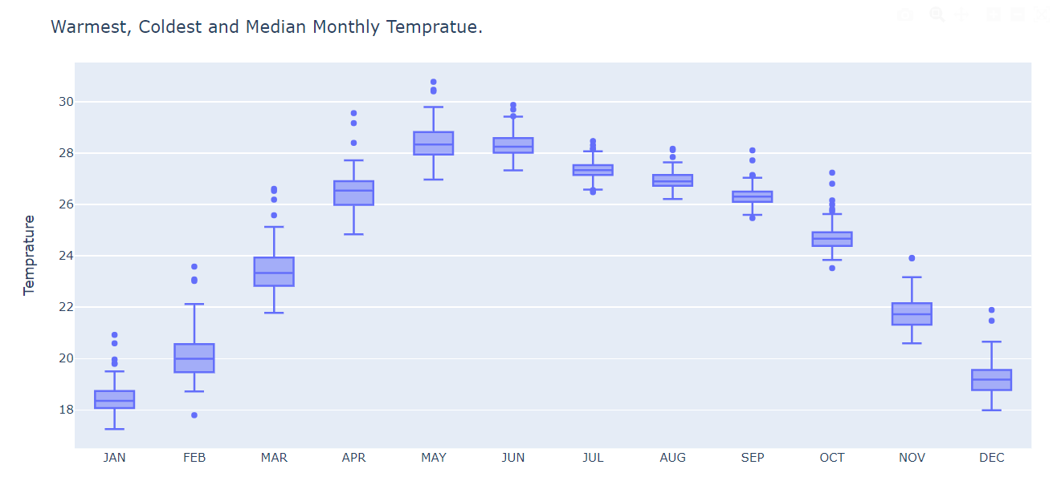

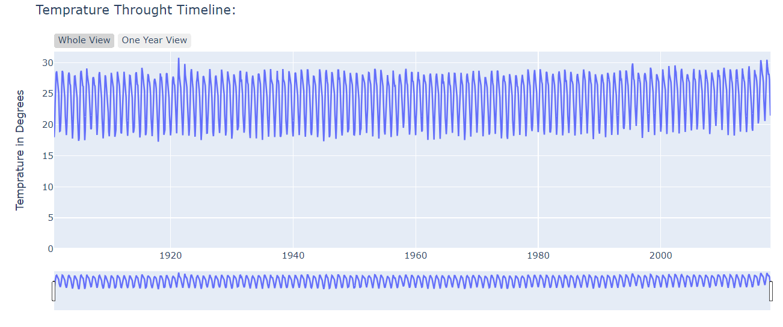

**Results:**

Data analysis and visualization of weather forecasting datasets have yielded notable results, including enhanced forecast accuracy through the application of machine learning and statistical modeling techniques. These methodologies have enabled meteorologists to identify recurring weather patterns and phenomena, leading to more reliable predictions of temperature fluctuations, precipitation levels, and wind patterns. Moreover, early warning systems for extreme weather events have been developed, leveraging historical data analysis and predictive modeling to issue timely alerts and optimize resource allocation for disaster preparedness and response. Through intuitive visualizations such as heatmaps and storm tracks, these insights are effectively communicated to the public and decision-makers, facilitating informed decision-making and enhancing resilience to weather-related hazards.

**Benefits of Data analysis and visualization of Weather Forcasting dataset:**

Data analysis and visualization of weather forecasting datasets offer numerous benefits, including:

1. **Improved Forecast Accuracy:** By analyzing historical weather data and current meteorological conditions, data analysis techniques such as statistical modeling and machine learning can improve the accuracy of weather forecasts.
2. **Enhanced Understanding of Weather Patterns:** Visualizing weather data allows meteorologists to gain insights into complex weather patterns and phenomena.
3. **Early Detection of Extreme Events:** Data analysis techniques can help identify early warning signs of extreme weather events such as hurricanes, tornadoes, or heatwaves. Visualization tools enable meteorologists to monitor weather conditions in real-time and detect anomalies that may indicate the onset of severe weather, allowing for timely warnings and preparation.
4. **Optimized Resource Allocation:** By analyzing historical weather data alongside other relevant factors such as population density and infrastructure vulnerability, decision-makers can optimize resource allocation for disaster preparedness and response. Visualization tools facilitate the identification of high-risk areas and the allocation of resources where they are most needed.
5. **Support for Climate Research:** Data analysis and visualization of weather forecasting datasets contribute to climate research by providing insights into long-term climate trends and variability. By analyzing historical weather data over extended periods, researchers can identify climate change impacts and inform mitigation and adaptation strategies.
6. **Public Awareness and Education:** Visualizations of weather data make complex meteorological concepts more accessible to the general public. Interactive maps, charts, and animations can help individuals understand weather forecasts and make informed decisions about activities such as travel, outdoor events, and agricultural practices.
7. **Decision Support for Various Sectors:** Weather forecasting data analysis supports decision-making in diverse sectors such as agriculture, transportation, energy, and tourism.

**LIMITATIONS AND FUTURE SCOPE**

Weather forecasting in data visualization faces challenges regarding data accuracy, the complexity of weather phenomena, visualization techniques, and user interpretation. Despite these limitations, the future scope is promising. Advancements in visualization technologies like augmented reality and predictive analytics can enhance the accuracy and reliability of forecasts. Personalized forecasting and collaborative visualization platforms offer opportunities for tailoring weather information to individual needs and facilitating real-time sharing and collaboration among stakeholders. With ongoing innovations, weather visualization systems have the potential to evolve into more intuitive, accurate, and accessible tools for decision-making and preparedness.

**Conclusion:**

In conclusion, while weather forecasting in data visualization faces various limitations, ongoing advancements in visualization techniques, predictive analytics, personalization, and collaboration offer promising opportunities for enhancing the accuracy, accessibility, and usability of weather forecast information in the future. By addressing these limitations and embracing emerging technologies, weather visualization systems can continue to evolve and improve, empowering individuals and organizations to make more informed decisions and better prepare for weather-related events.